**Sprint-3**

|  |  |
| --- | --- |
| **Date** | **6 November 2022** |
| **Team Id** | **PNT2022TMID13490** |
| **Project Name** | **Gas Leakage Monitoring and Alerting System** |

**Testing and Training :**

int greenLed = 12; int buzzer = 11; int smokeA0 = A0; void setup()

{

pinMode(greenLed, OUTPUT); pinMode(buzzer, OUTPUT); pinMode(smokeA0, INPUT);

Serial.begin(9600);

} void loop() { int analogSensor = analogRead(smokeA0);

Serial.print("Gas Level: "); Serial.println(analogSensor); if (analogSensor > 682 && analogSensor < 719)

{

digitalWrite(greenLed, LOW); tone(buzzer, 3000, 200);

}

else if(analogSensor > 720)

{

digitalWrite(greenLed, LOW); tone(buzzer, 1000, 200);

}

else

{

digitalWrite(greenLed, HIGH); noTone(buzzer);

}

delay(100);

}

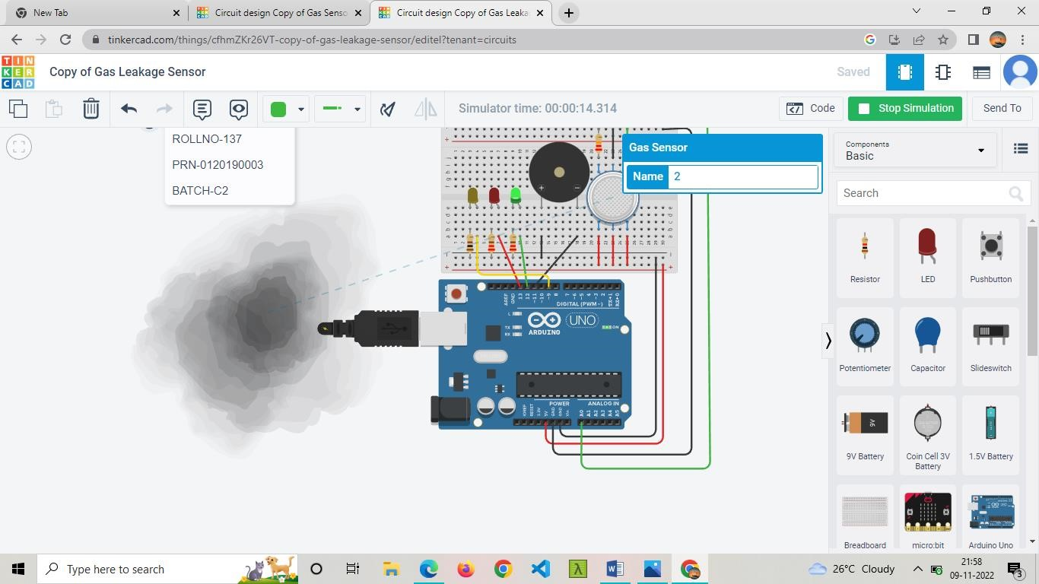

The Programmer can design an gas leakage detection model.